#include <stdio.h>

int main()

{

int a[5]={1,2,3,4,5};

printf(" a:%d \n \*a:%d \n a+1:%d \n \*a+1:%d \n \*(a+1):%d \n a[2]+1:%d \n \*(a+1)+1:%d \n",a,\*a,a+1,\*a+1,\*(a+1),a[2]+1,\*(a+1)+1);

return 0;

}

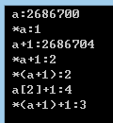

#include <stdio.h>

int main()

{

int a[3][4]={{1,3,5,7},{9,11,13,15},{17,19,21,23}};

printf(" a:%d \n \*a:%d \n a+1:%d \n \*a+1:%d \n \*(a+1):%d \n a[2]+1:%d \n \*(a+1)+1:%d \n",a,\*a,a+1,\*a+1,\*(a+1),a[2]+1,\*(a+1)+1);

printf(" \*(\*(a+2)+2):%d \n",\*(\*(a+2)+2));

return 0;

}

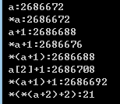

printf("&a:%d,&a[0]:%d \n",&a,&a[0]);

printf("a:%d,a[0]:%d \n",a,a[0]);

printf("\*a:%d,\*a[0]:%d \n",\*a,\*a[0]);

printf("\*\*a:%d \n",\*\*a);

